Laying cables quickly and installing operating elements with ease
Flexible design and easy adaptation of machine cabins

Machine cabins have two functions – protecting the processes inside and the area outside the cabins. The ideal scenario is when the frame shape and equipment can be adapted to the work process and flexibly modified as required. Exactly this scenario can be achieved with the item building kit system, which offers perfectly coordinated individual components. Laying cables is made easier thanks to cable conduits accessible from the outside and special intersection point connectors. Machinery inside the cabin can therefore be connected with ease. Installing switches and other operating elements is also much simpler.

Different processes need different enclosures. Some machine cabins are needed for multiple-stage working processes in linear applications, for example, or for rotary applications on rotary tables. Whether square, rectangular or octagonal, narrow and compact or large and expansive – enclosures can be built in custom shapes with the aluminium profiles and screwed connections from item. Line XMS ensures perfect adaptability to the working process. The machine cabins can be divided into several areas with different functions. Special door profiles provide easy access to the individual process sections. The series-standard sealing groove means the interior is kept clean and dust-free.

Easy laying of cables from the outside
item has expanded its portfolio of products for the customised design of machine cabins by adding construction profiles X 8 M45 - XMS. The result is cable conduits accessible from the outside. This means cables can be laid with ease, and integrating operating and control elements is a simple process, too. The profiles can be sealed with suitable Cover Profiles, thereby ensuring the cables are kept safe and protected. Factory equipment engineers can choose from a range of design variants. The profiles with integrated cable conduits come in various sizes and are now available in two variants – one with the open side facing in and the other with the open side facing out. However, they have one thing in common – the sealed, smooth and easy-to-clean surface.

Quickly connecting machinery and integrating operating elements with ease
Thanks to the use of special Fastening Sets, stable intersection points are created in the frame, making switching from a horizontal to a vertical direction, or vice versa, a quick and easy process when laying cables. The intersection points also function as cable feed-throughs, thereby ensuring the straightforward connection of the equipment inside the cabin. Control and operating elements can be attached directly on the outside of the frame and connected with cables. Electrical components from the M45 standard system can also be integrated, thanks to the clip geometry of item profiles. Many switch, display and operating elements from different manufacturers can therefore be used. All components simply clip into place and can be removed and used elsewhere if required. This provides maximum flexibility.

The numerous aluminium profile variants and extensive accessories with their sophisticated look offer factory equipment engineers extensive design freedom and the option to adjust the machine cabin to suit changing requirements at any time. The machine cabin can also be divided into sections to be transported to the customer and then quickly reassembled on site. The result is machine enclosures in many different shapes with a visually appealing design. The following video demonstrates the many benefits of item machine cabins:
https://youtu.be/jjspc9pqTnw

Length: 3,749 characters including spaces
Date: 25 October 2021

Photos: 3 (source: item)

Caption 1: Whether square, rectangular or octagonal, narrow and compact or large and expansive – Line XMS from item ensures perfect adaptability to the working process.

Caption 2+3: Thanks to cable conduits accessible from the outside, cables can be laid with ease – and integrating operating and control elements is a straightforward process, too.

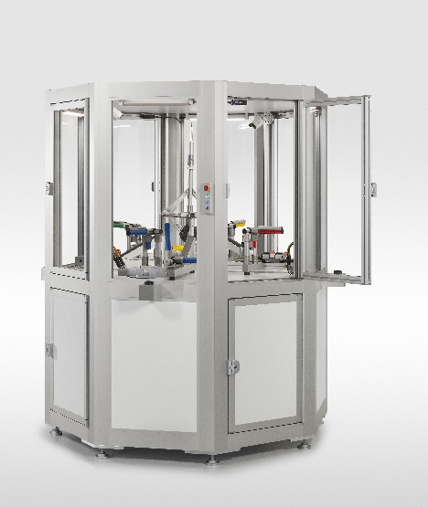
Image 1

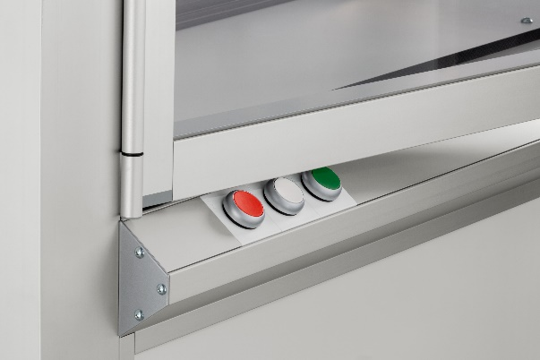
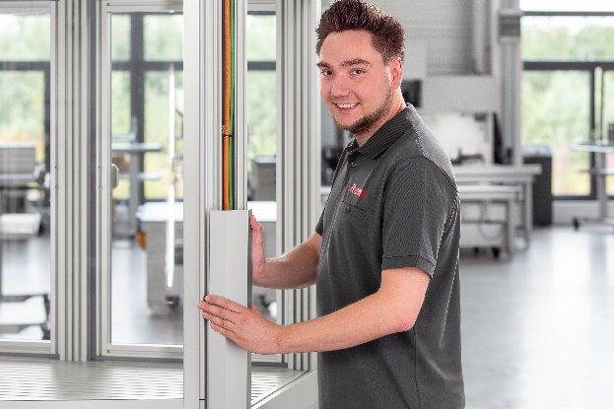

Image 2 Image 3

About item
item Industrietechnik GmbH is the pioneer in building kit systems for industrial applications and a partner of the manufacturing industry across the entire globe. Today, the item product portfolio comprises more than 4,000 high-quality components designed for use in machine bases, work benches, automation solutions and lean production applications. The company has received a string of awards for products with ground-breaking industrial design and end-to-end ergonomics.

item is spearheading digital engineering by driving forward the digitalisation of processes with software tools developed in-house. The item Academy offers training at various levels, with on-demand training and online courses available in multiple languages.

Headquartered in Solingen, Germany, item has subsidiaries in various countries. Some 900 employees worldwide harness their know-how and passion to develop innovative solutions and services. Twelve sites make sure the company is always close to customers in Germany, with a global logistics chain ensuring swift delivery times for all components.

Company contact
Nicole Hezinger • item Industrietechnik GmbH
Friedenstrasse 107 - 109 • 42699 Solingen • Germany
Tel.: +49 212 65 80 5188 • Fax: +49 212 65 80 310
Email: n.hezinger@item24.com • Internet: www.item24.com

Press contact
Jan Leins • additiv pr GmbH & Co. KG
Press work for logistics, steel, industrial goods and IT
Herzog-Adolf-Strasse 3 • 56410 Montabaur • Germany
Tel.: (+49) 26 02-95 09 91 6 • Fax: (+49) 26 02-95 09 91 7
Email: jl@additiv-pr.de • Internet: www.additiv-pr.de/maschinenbau

