Reliable material transport
Versatile conveyor belt systems for a wide range of applications

A lot of the work at production and logistics centres involves moving goods from A to B. Regardless of their size, weight and shape, they need to reach their destination both quickly and reliably. The item Building Kit System offers virtually unlimited options when it comes to finding the best possible transport solution for every task and application. One new addition to the portfolio is the item Conveyor Belt System, which combines durability with efficient, low-maintenance operation.

The new Conveyor Belt System from item reliably transports everything from production parts to small load carriers. The company from Solingen in Germany has now added a large number of components for cutting-edge conveyor belt systems to the item Building Kit System. The Flat Belt Conveyor, for instance, can reliably transport even goods and containers with irregular bases.

Configured with different surfaces
The Flat Belt Conveyor consists of a basic frame made from aluminium profiles, plus return and drive assemblies, a glide plate and the conveyor belt. It is powered by an asynchronous three-phase AC motor that is available in two designs and can be optimised to suit the relevant requirements. Transport speeds ranging from 2.5 m/min to almost 30 m/min can be achieved. The glide plate serves both a protective and a supporting function, increasing the conveyor belt’s wear resistance. Belts are available with either an adherent or a non-adherent surface. If the goods being transported are to accumulate on the belt, it must be able to continue moving freely underneath them to ensure a continuous flow of goods. For non-accumulating systems, item offers conveyor belts with an adherent surface that make it possible to securely transport goods and containers at a gradient of up to 20°.

Numerous variants for different uses
Besides the Flat Belt Conveyor, a number of other conveyor systems are also available. The Timing Belt Conveyor with a width of either 40 mm or 80 mm, for instance, is primarily designed to transport heavy goods. Timing Belt Guide Strips keep the belt on track, while the Drive Pulley creates a mechanically locked connection, which means high loads can be transferred to the belt. Both a Double Flat Belt Conveyor and a Double Timing Belt Conveyor are also available to transport dimensionally stable goods and containers. In this case, two belts spaced up to 2400 mm apart run in sync.

Combination with linear axis and other system components
With its Range Extender project, item has implemented its own combined application at company headquarters in Solingen. Next to a Flat Belt Conveyor 6000 mm long is a linear axis on which a cobot moves in sync with the conveyor belt. It removes components from the belt and rearranges them without interrupting the movement of the belt. The Flat Belt Conveyor is followed by a roller conveyor on which the finished workpiece continues its journey. As this example demonstrates, the modular approach to design means item components can be used to create numerous conveyor sections for a variety of applications. The systems are designed for a long service life and benefit from virtually maintenance-free operation.

Length: 3,425 characters including spaces
Date: 16 March 2022

Photos: 5 (source: item)

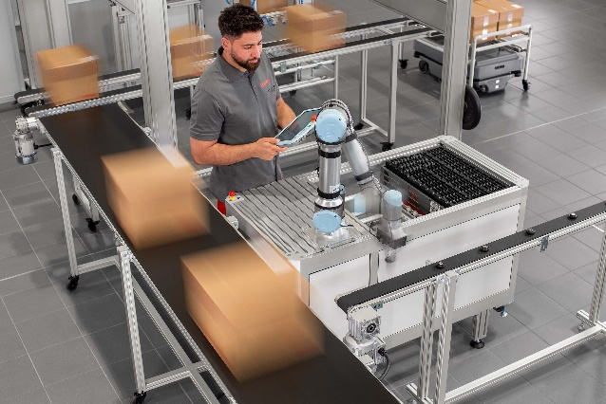
Caption 1: The new item Conveyor Belt System ensures reliable material transport.

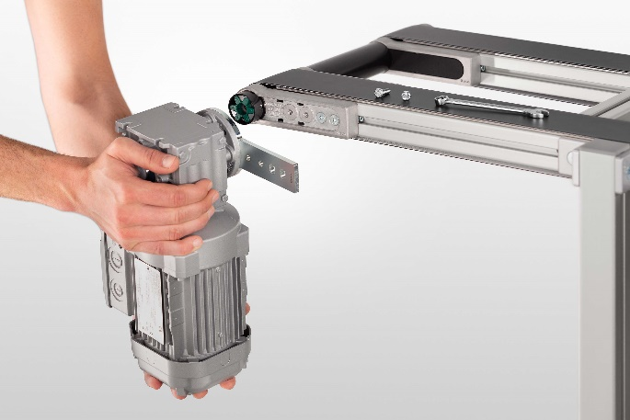
Caption 2: The conveyor belt is powered by an asynchronous three-phase AC motor that is available in two designs and can be optimised to suit the relevant requirements.

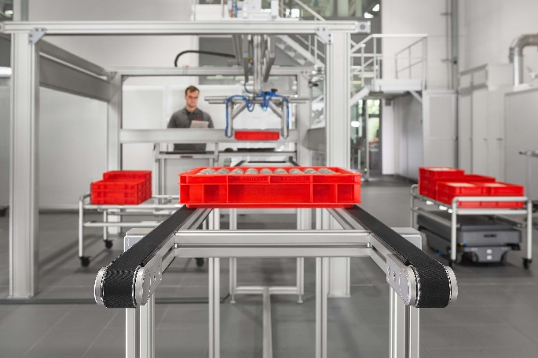
Caption 3: There are four different versions of the item Conveyor Belt System. Besides the standard Flat Belt Conveyor, a Timing Belt Conveyor is also available and each of these solutions has a variant with a double conveyor to transport dimensionally stable goods and containers.

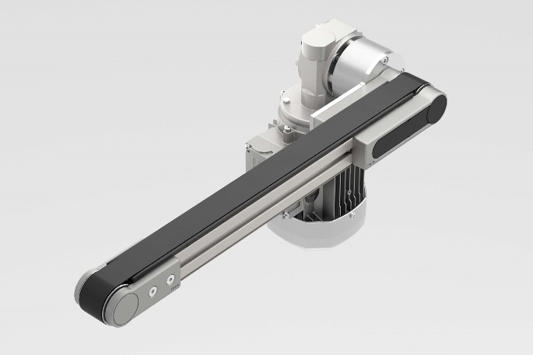
Caption 4: The Timing Belt Conveyor is available in widths of 40 mm and 80 mm and is primarily designed to transport heavy goods.

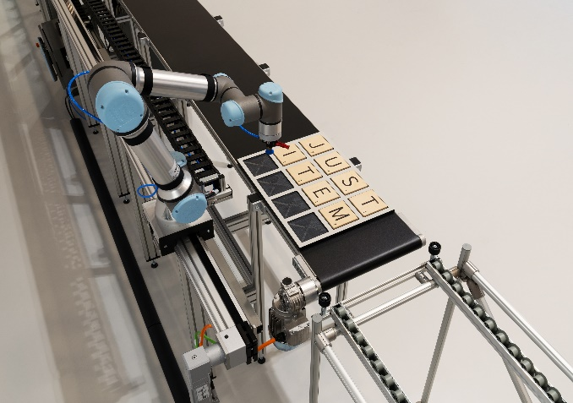
Caption 5: One example of an actual application is the Range Extender project, which features a cobot that moves in parallel to the Flat Belt Conveyor on a linear axis. Keeping in sync with the belt, the robot removes components and rearranges them.

About item
item Industrietechnik GmbH is the pioneer in building kit systems for industrial applications and a partner of the manufacturing industry across the entire globe. Today, the item product portfolio comprises more than 4,000 high-quality components designed for use in machine bases, work benches, automation solutions and lean production applications. The company has received a string of awards for products with ground-breaking industrial design and end-to-end ergonomics.

item is spearheading digital engineering by driving forward the digitalisation of processes with software tools developed in-house. The item Academy offers training at various levels, with on-demand training and online courses available in multiple languages.

Headquartered in Solingen, Germany, item has subsidiaries in various countries. Some 900 employees worldwide harness their know-how and passion to develop innovative solutions and services. Twelve sites make sure the company is always close to customers in Germany, with a global logistics chain ensuring swift delivery times for all components.

Company contact
Nicole Hezinger • item Industrietechnik GmbH
Friedenstrasse 107 - 109 • 42699 Solingen • Germany
Tel.: +49 212 65 80 5188 • Fax: +49 212 65 80 310
Email: n.hezinger@item24.com • Internet: www.item24.com

Press contact
Jan Leins • additiv pr GmbH & Co. KG
Press work for logistics, steel, industrial goods and IT
Herzog-Adolf-Strasse 3 • 56410 Montabaur • Germany
Tel.: (+49) 26 02-95 09 91 6 • Fax: (+49) 26 02-95 09 91 7
Email: jl@additiv-pr.de • Internet: www.additiv-pr.de/maschinenbau

